FAST-NUCES KARACHI CAMPUS
(FALL-2025)


(CS-3004) SOFTWARE DESIGN & ANALYSIS

COURSE PROJECT:
[CAR DEALERSHIP MANAGEMENT SYSTEM]

SECTION:
BS-CS-5A

INSTRUCTORS:
ENGR ABDUL RAHMAN

PROJECT MEMBERS:
23K-0907 Zubair Ahmed
23K-0516 Usman Khalid
23K-0668 Mujtaba Khan

SRS IEEE TEMPLATE DIAGRAMS
ENTITY RELATIONSHIP DIAGRAM (DATABASE)
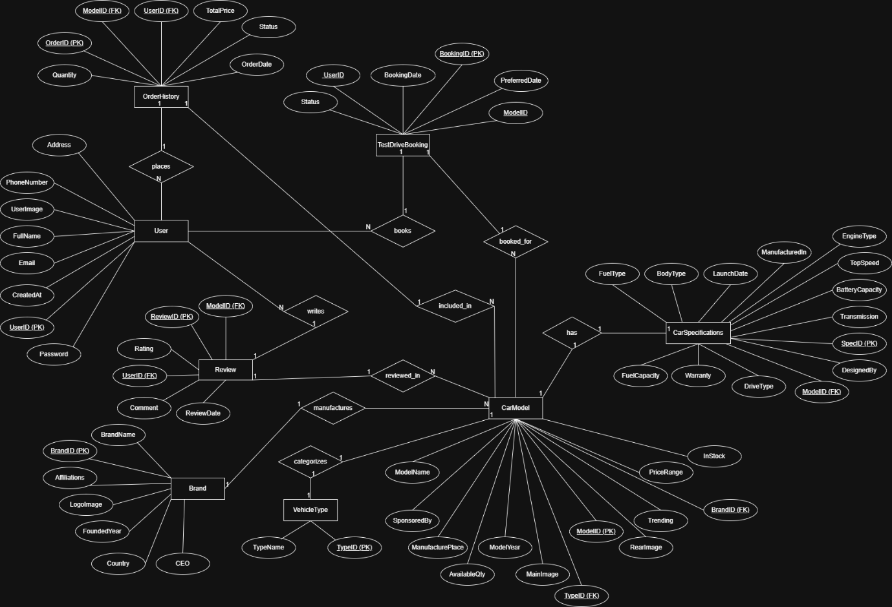

ACTIVITY DIAGRAM 1 (VEHICLE SEARCH ENGINE)
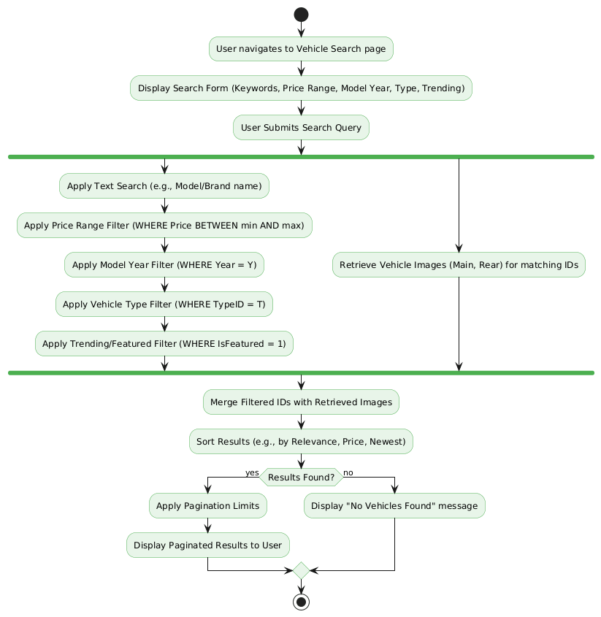

ACTIVITY DIAGRAM 2 (TEST DRIVE APPOINTMENT BOOKING)
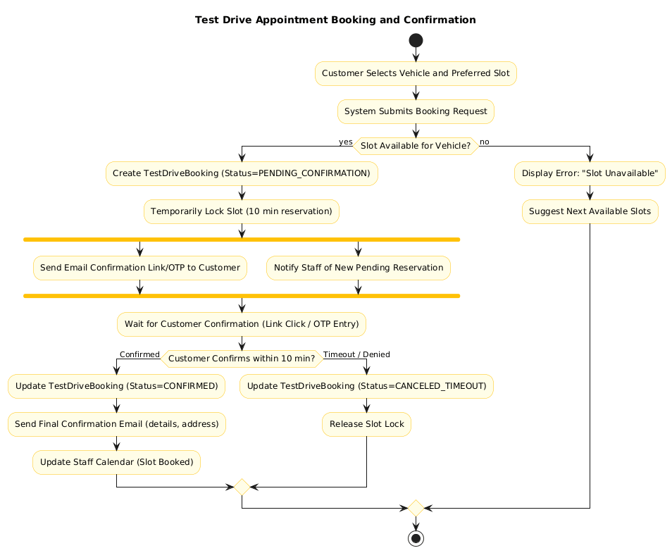

ACTIVITY DIAGRAM 3 (TWO-PHASE ORDER & INVENTORY)
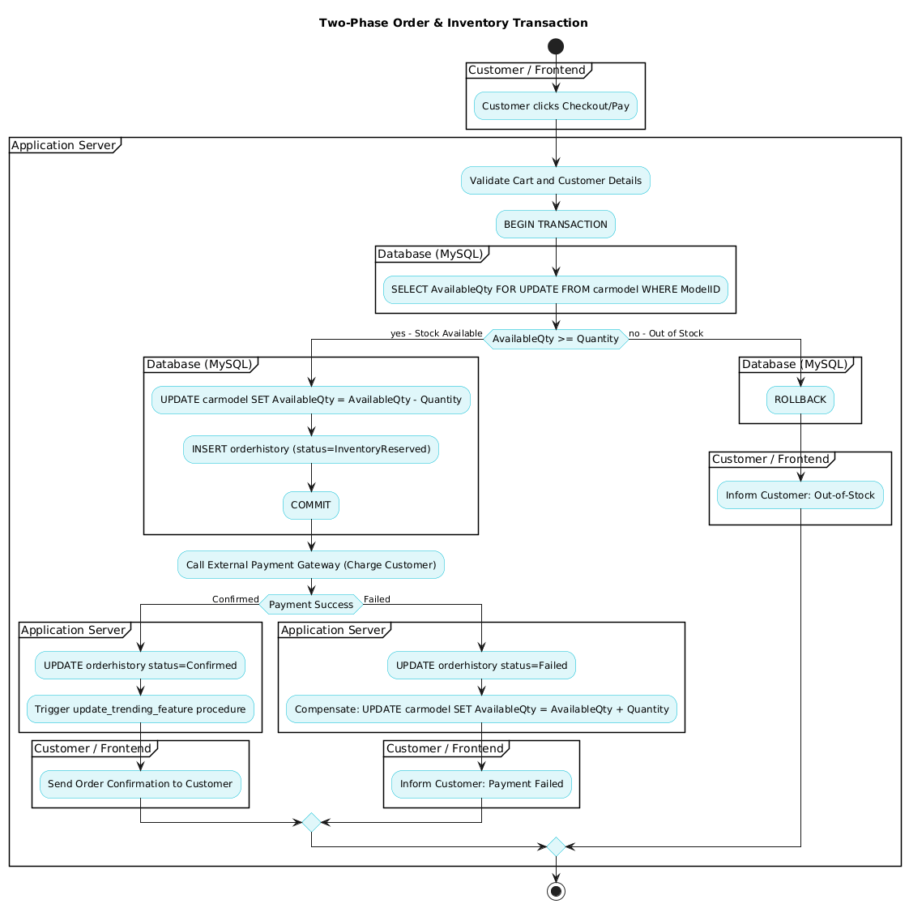

ACTIVITY DIAGRAM 4 (ORDERHISTORY TRIGGER)
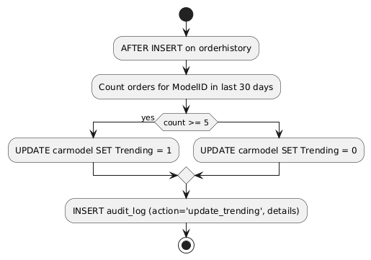

COLLABORATION DIAGRAM 1 (SEARCH VEHICLES WITH FILTERS)
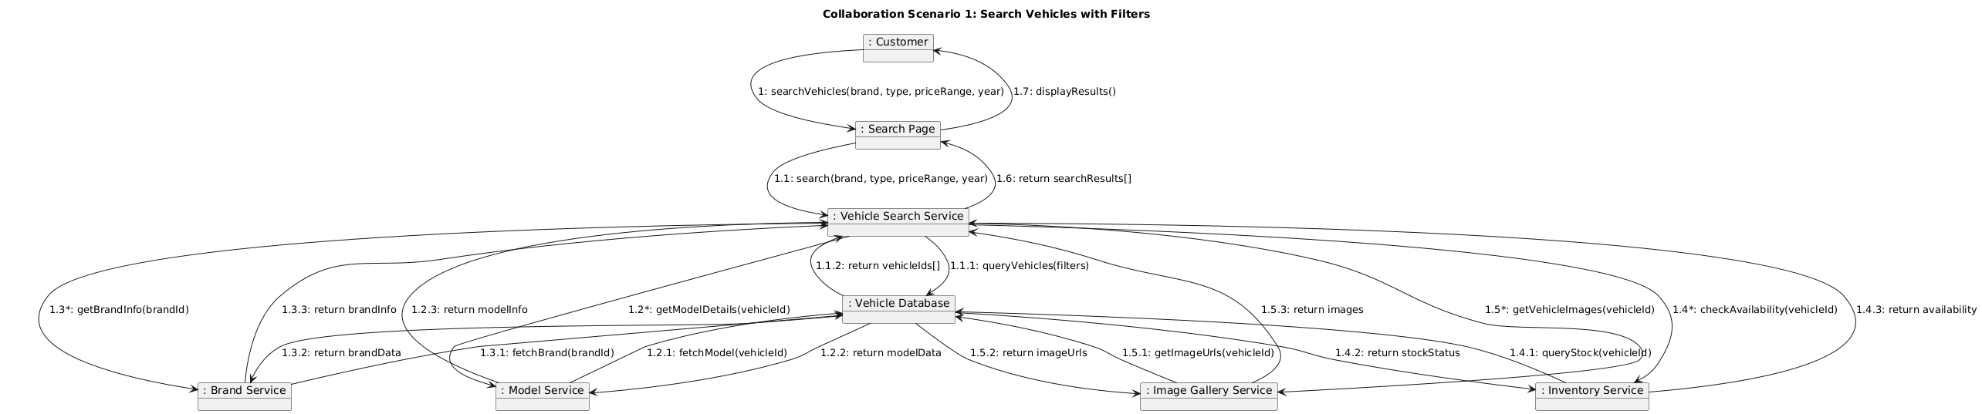

COLLABORATION DIAGRAM 2 (VIEW VEHICLE DETAILS)
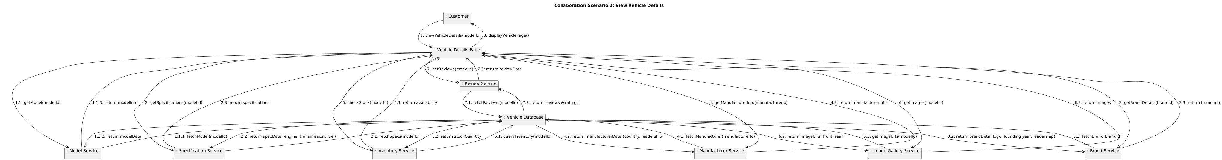

COLLABORATION DIAGRAM 3 (BOOK TEST DRIVE)
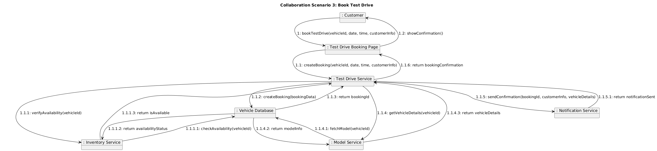

COLLABORATION DIAGRAM 4 (MANAGE FEATURE VECHICLE)
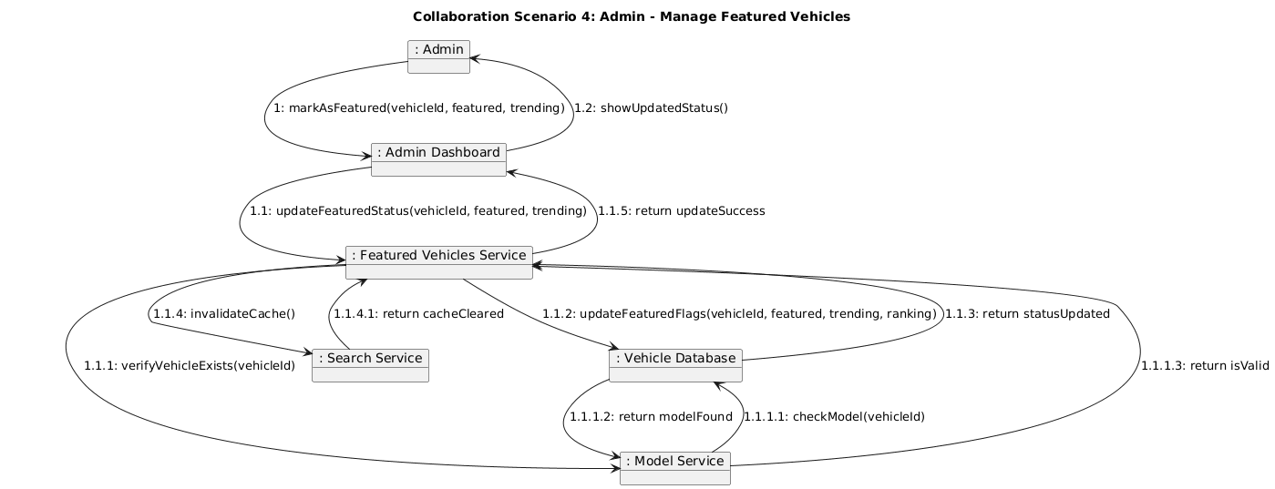

COLLABORATION DIAGRAM 5 (SUBMIT REVIEW)
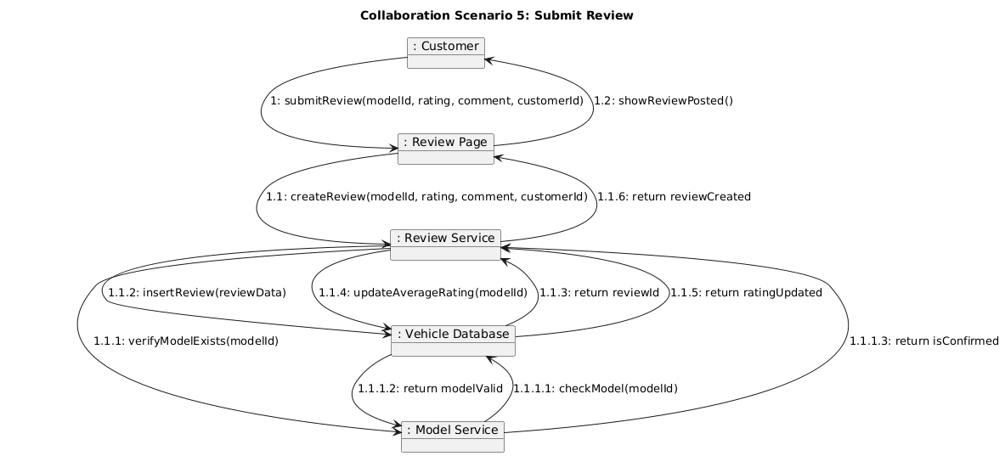

COLLABORATION DIAGRAM 6 (UPDATE INVENTORY)
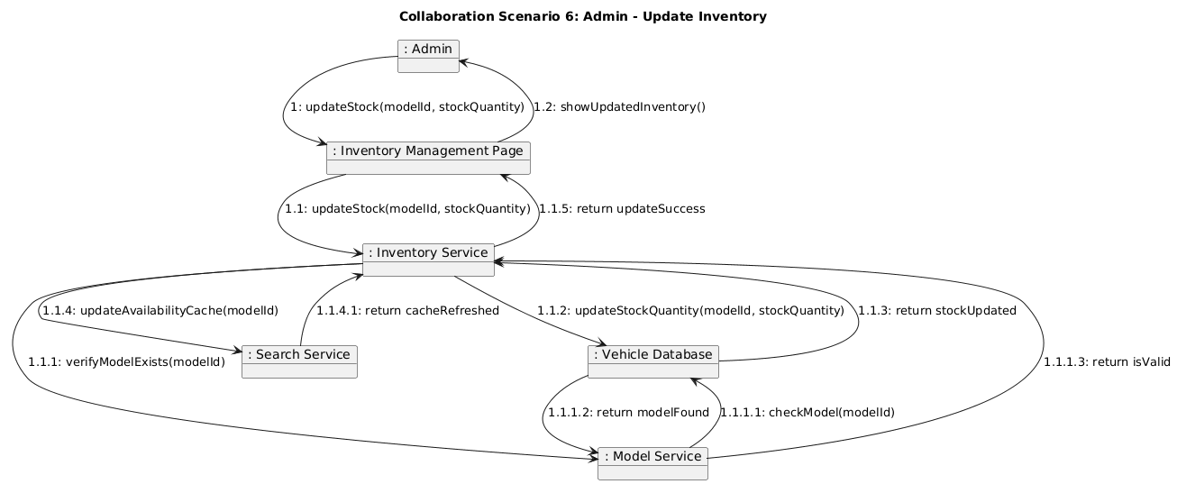

COLLABORATION DIAGRAM 7 (VIEW ORDER HISTORY)
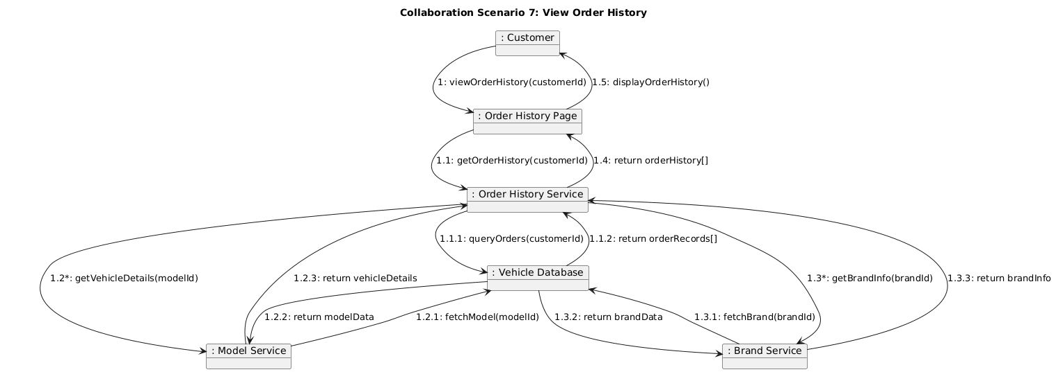

COLLABORATION DIAGRAM 8 (MANAGE BRAND & MANUFACTURER)
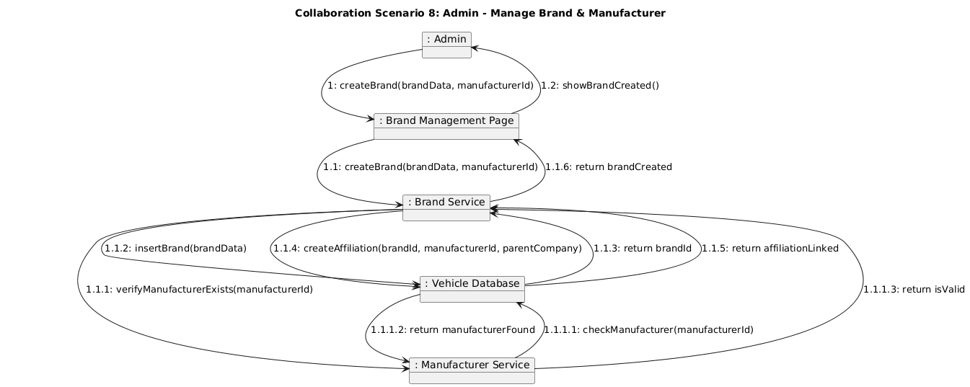

DEPLOYMENT DIAGRAM 1 (HIGH AVAILABITIY DEPLOYMENT)
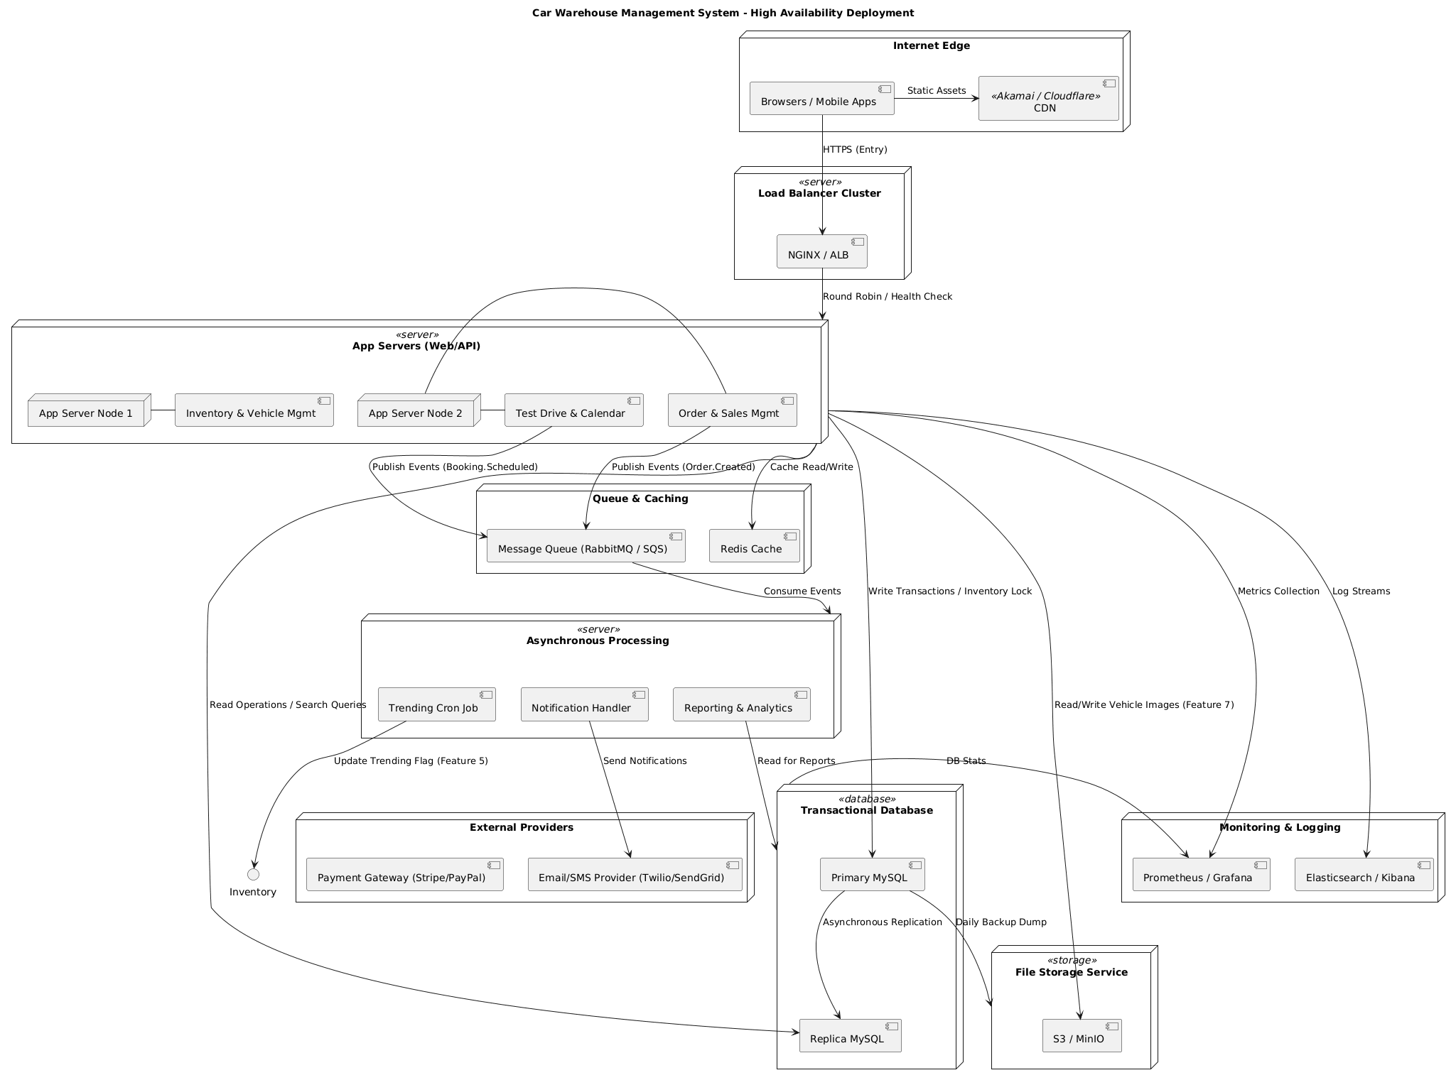

DEPLOYMENT DIAGRAM 2 (VEHICLE MANAGEMENT PLATFORM)
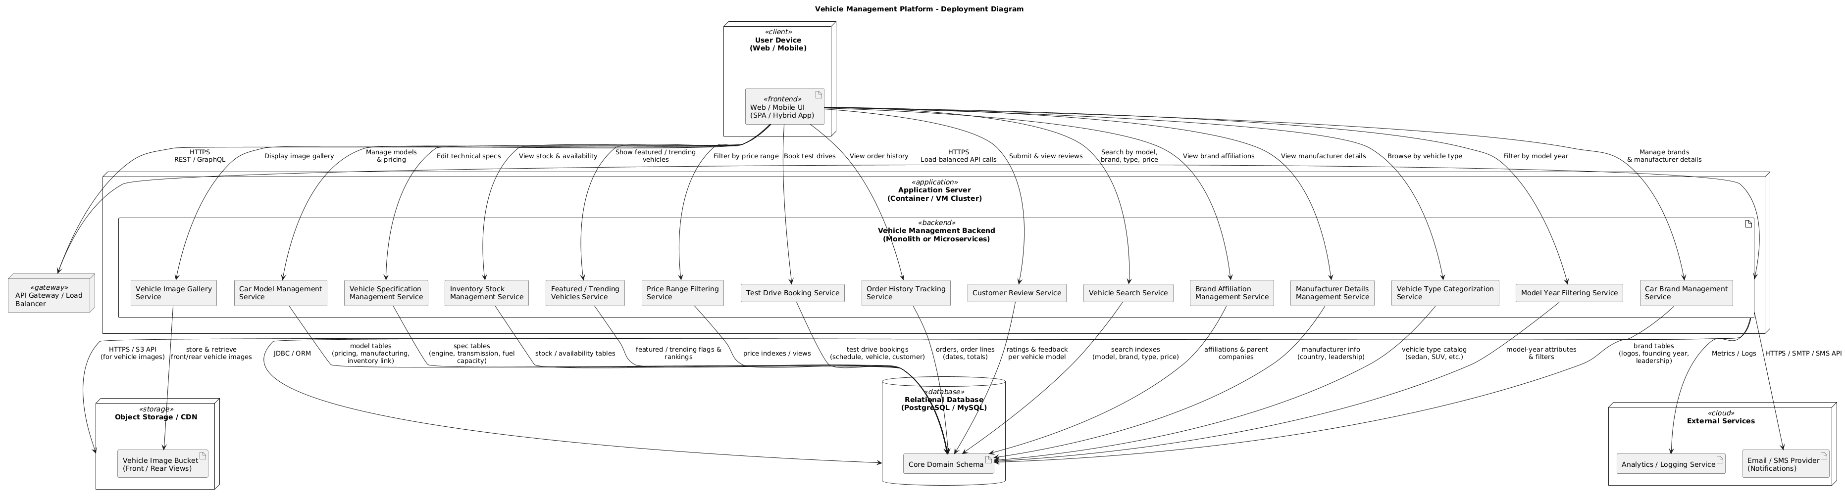

COMPONENT DIAGRAM 1 (SYSTEM ARCHITECTURE)
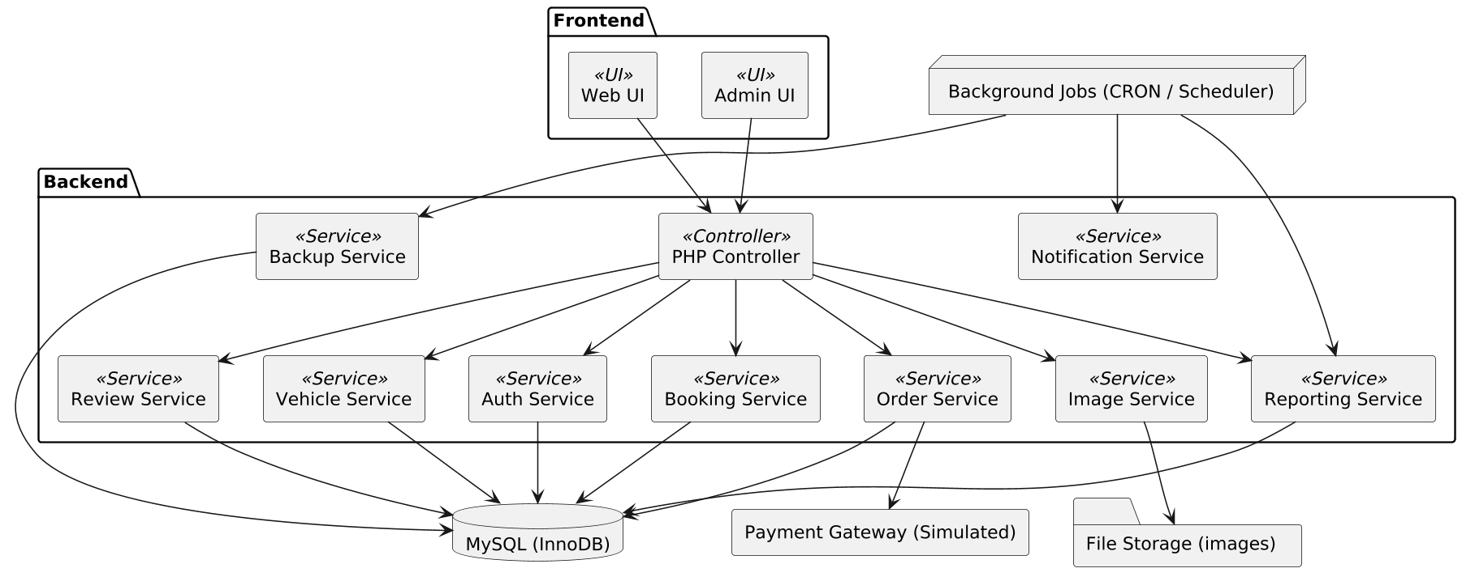

COMPONENT DIAGRAM 2 (MICROSERVICES & GATEWAYS)
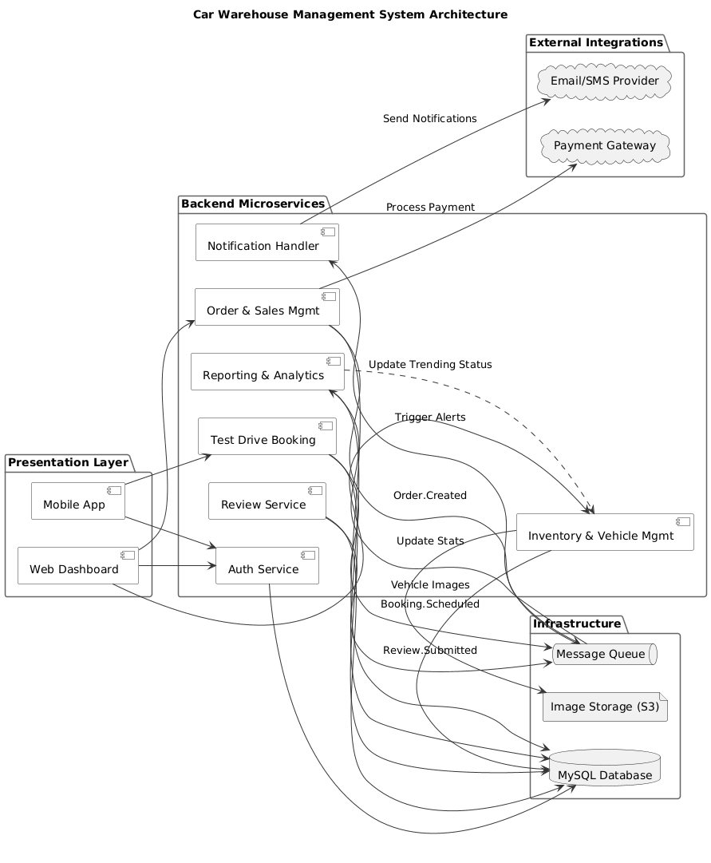

SEQUENCE DIAGRAM 1 (AUTHENTICATION + LOGIN/LOGOUT)
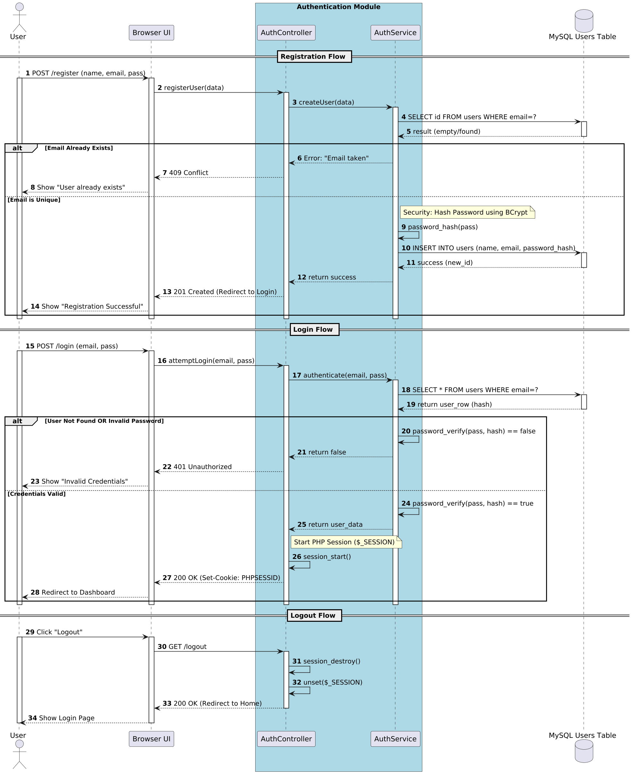

SEQUENCE DIAGRAM 2 (BACKEND APPLICATION)
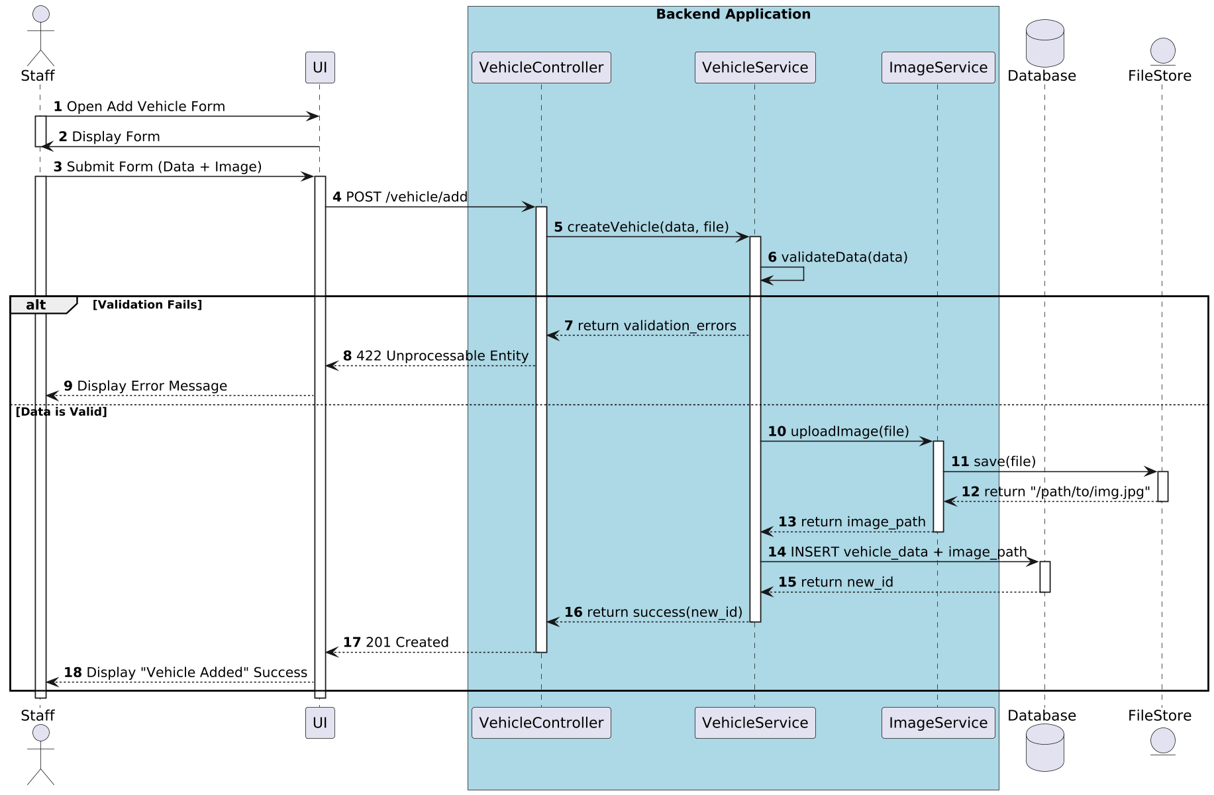

SEQUENCE DIAGRAM 3 (BACKEND LOGIC)
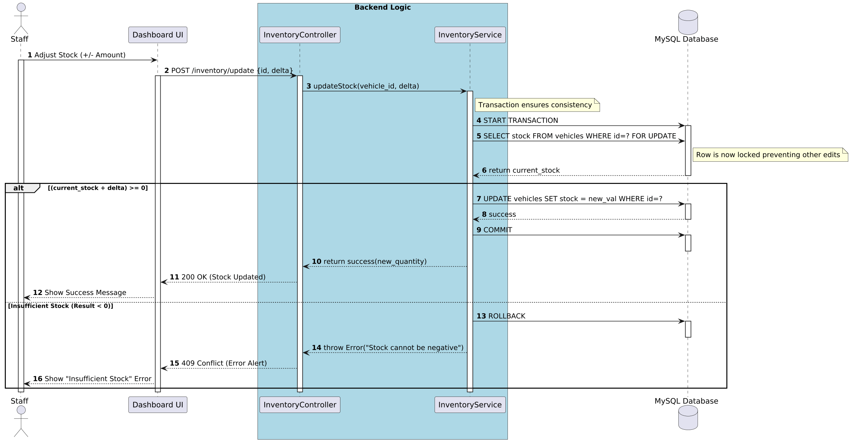

SEQUENCE DIAGRAM 4 (BACKEND SYSTEM)
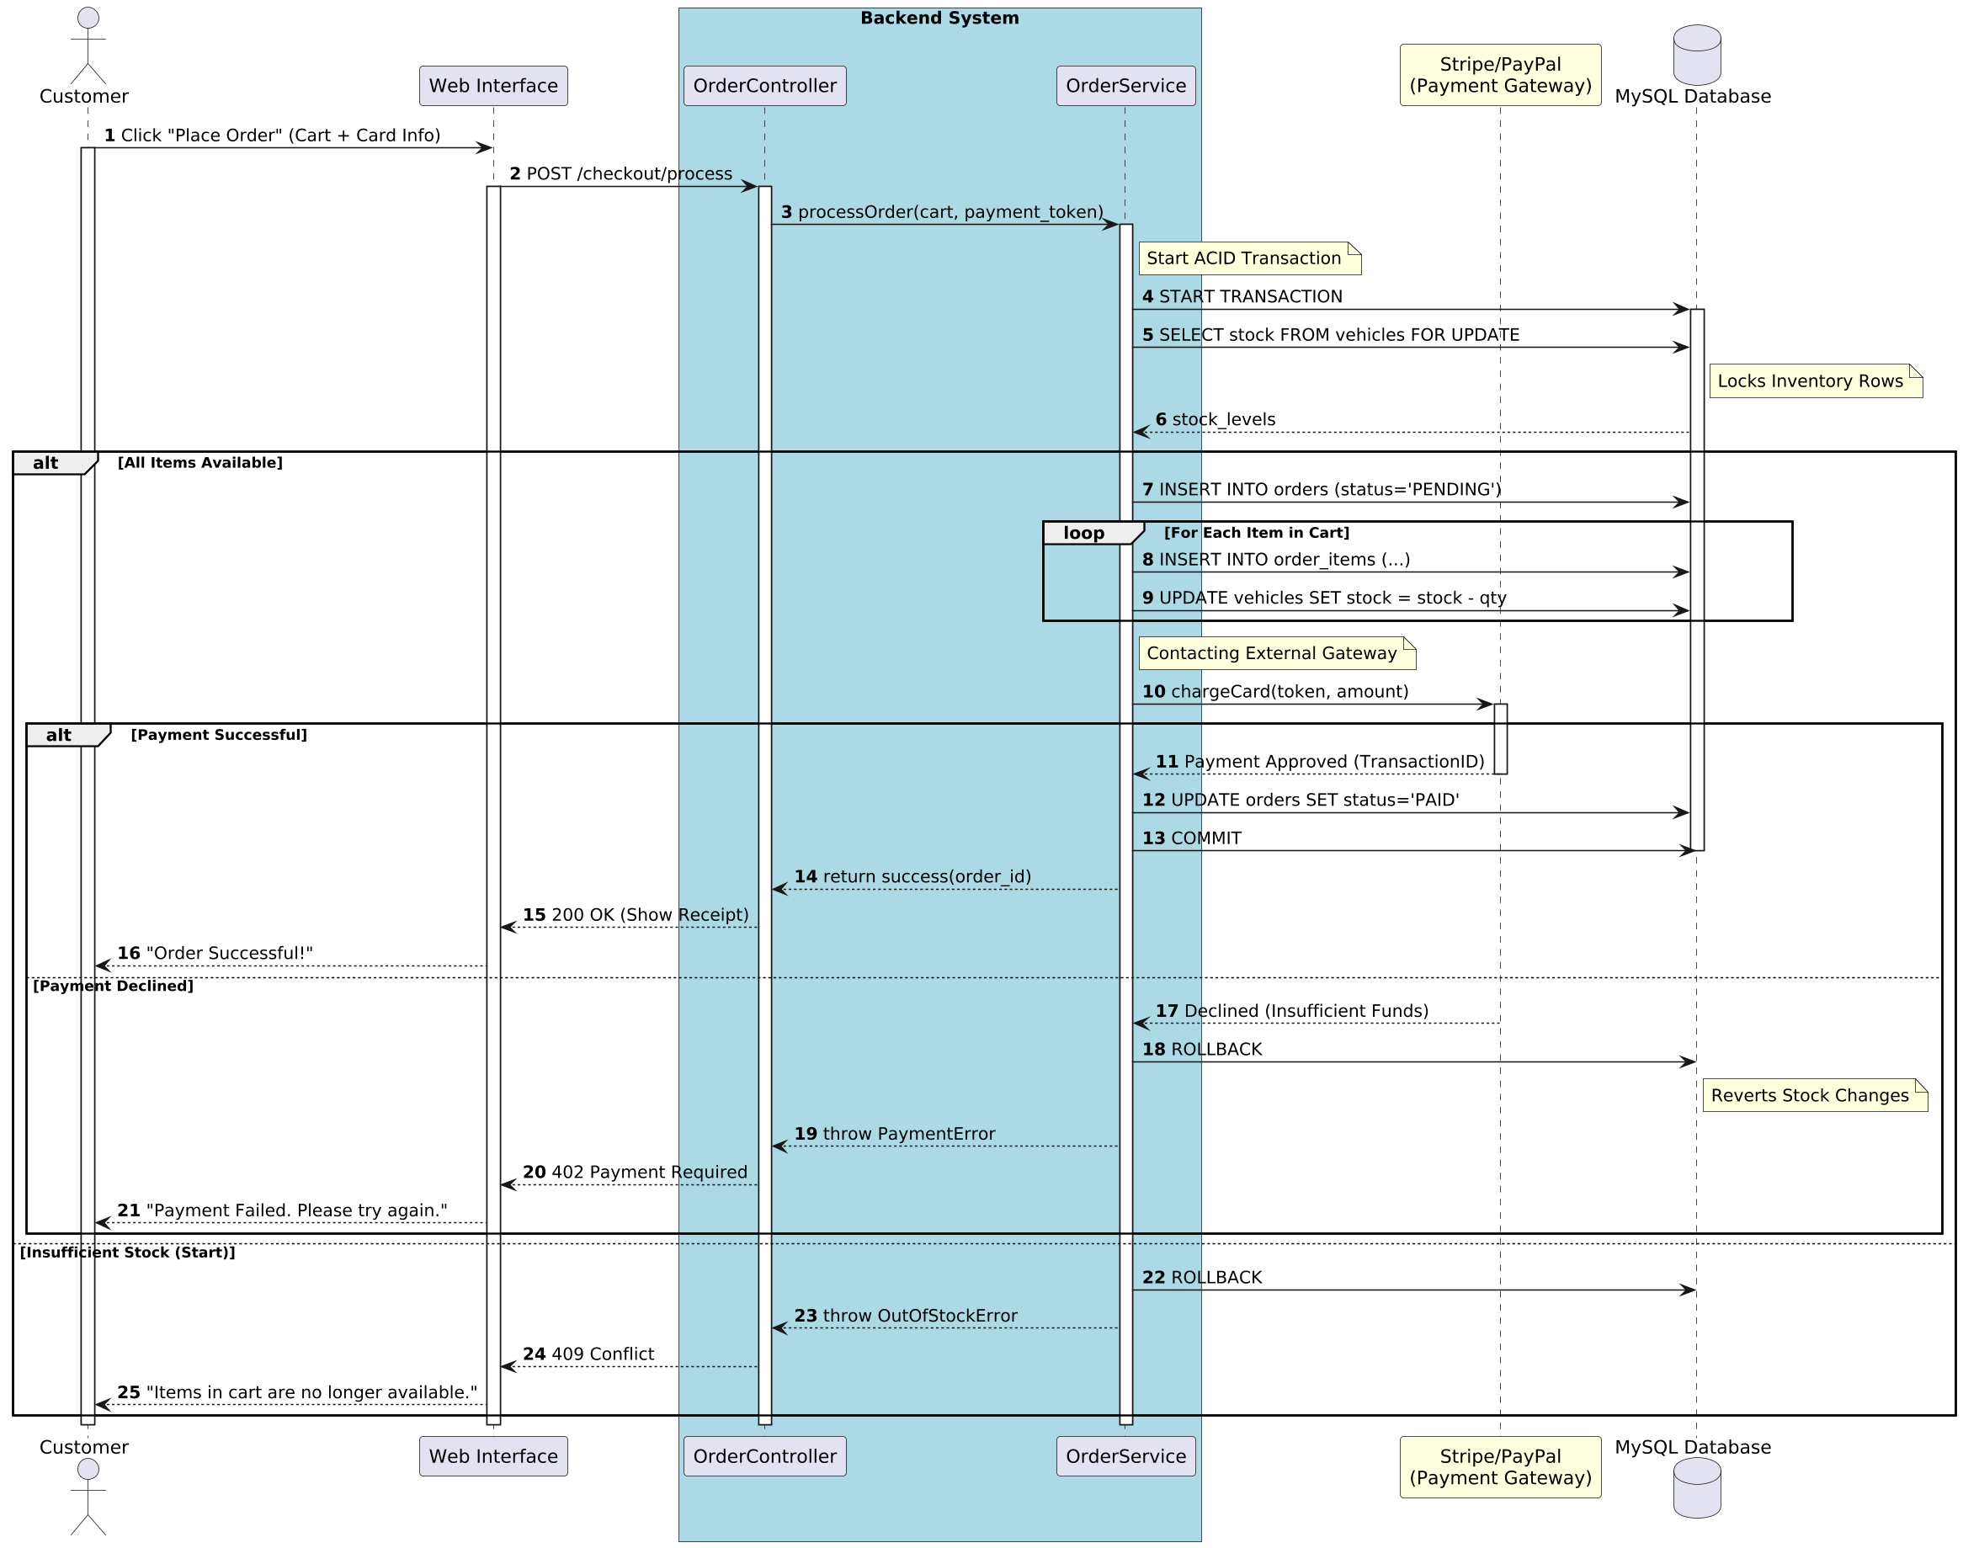

SEQUENCE DIAGRAM 5 (BACKEND SYSTEM – EXTENDED)
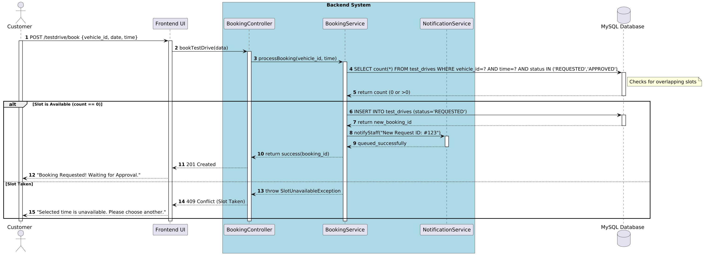

SEQUENCE DIAGRAM 6 (STAFF MODERATION)
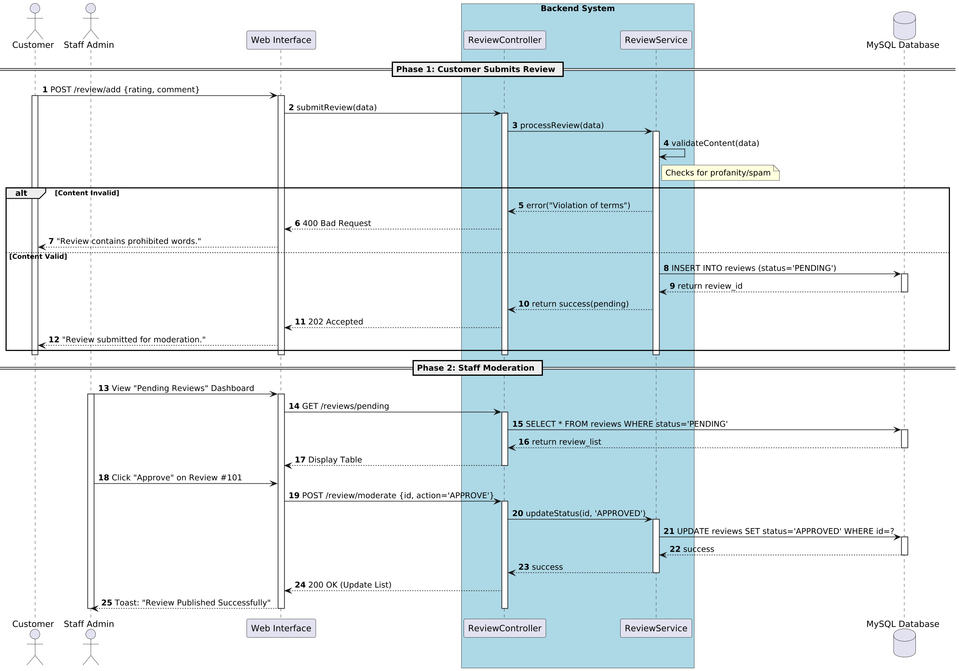

SEQUENCE DIAGRAM 7 (FEATURES - TRENDING VEHICLE)
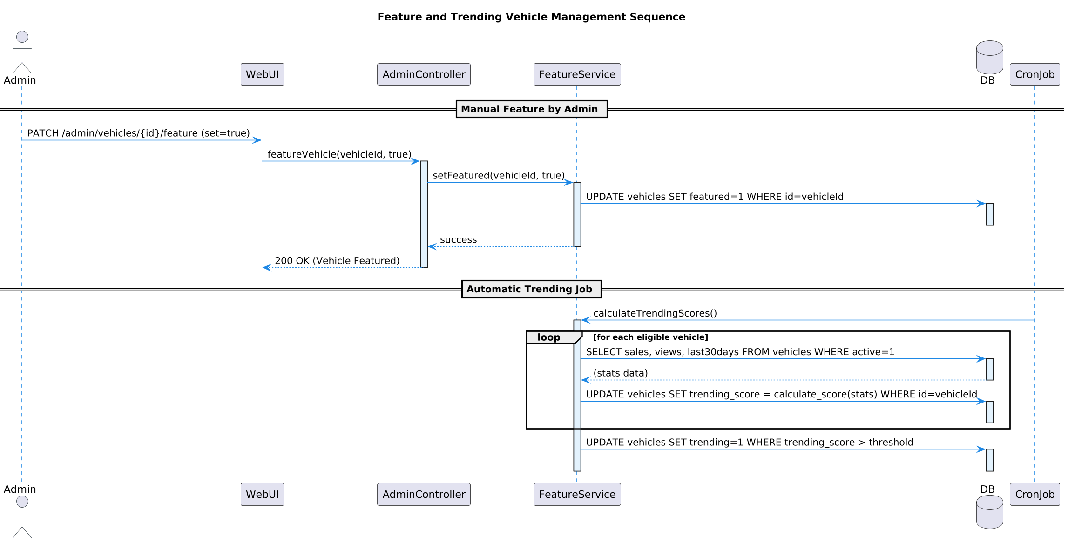

STATE MACHINE DIAGRAM 1 (CHARACTER CAPABILITIES)
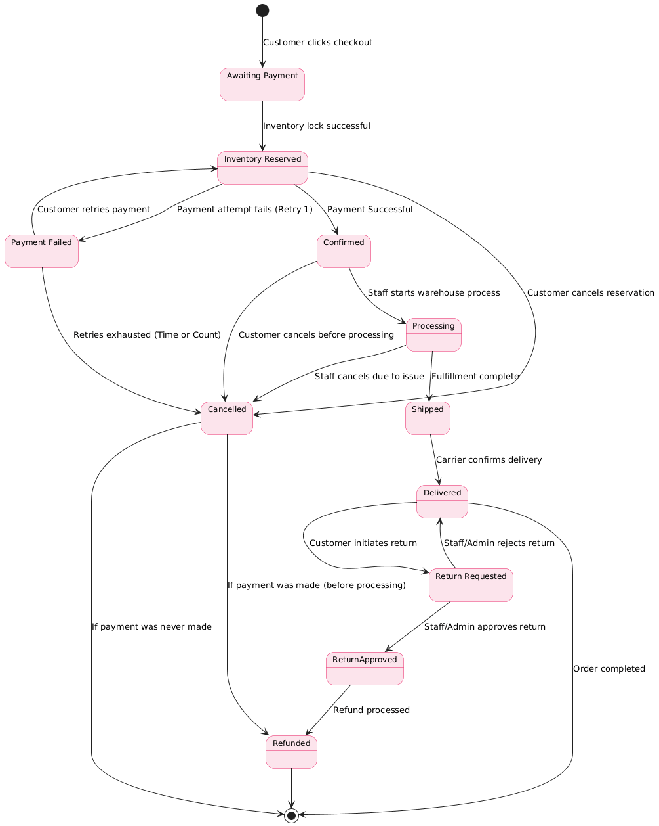

STATE MACHINE DIAGRAM 2 (STAFF CAPABILITIES)
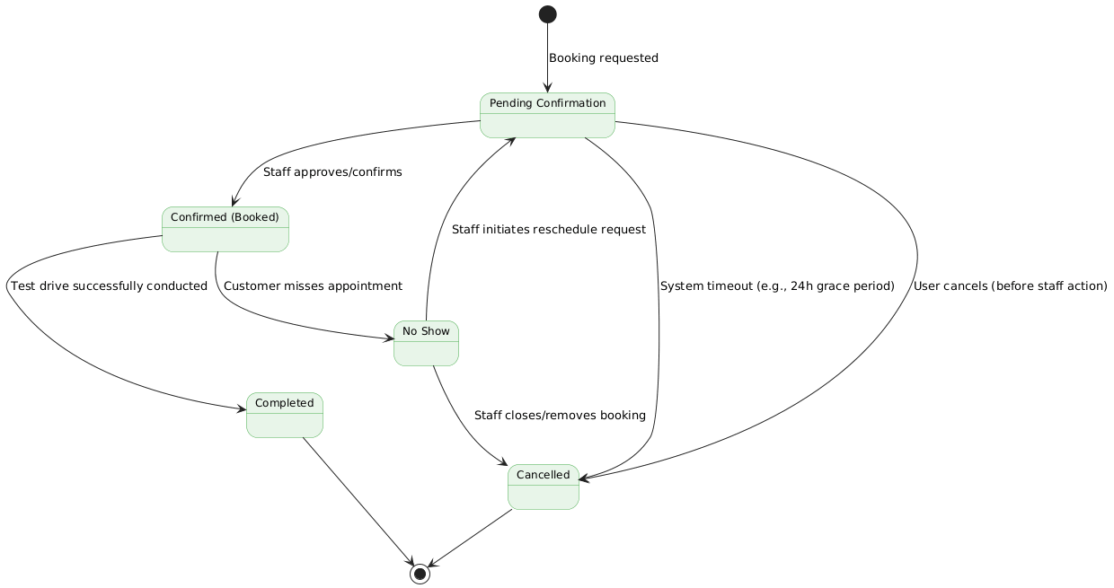

TIMING DIAGRAM 1 (ORDER PROCESS & INVENTORY UPDATE)
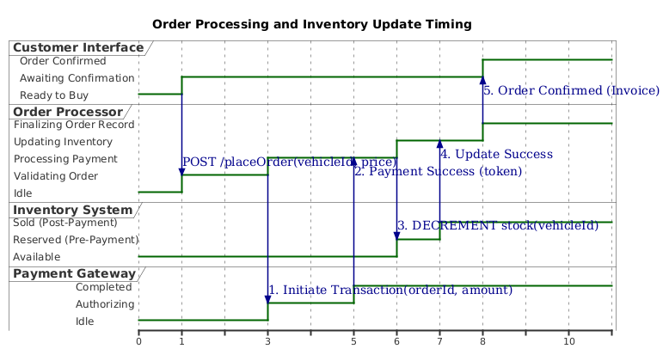

TIMING DIAGRAM 2 (ORDER FLOW WITH PAYMENT RETRIES)
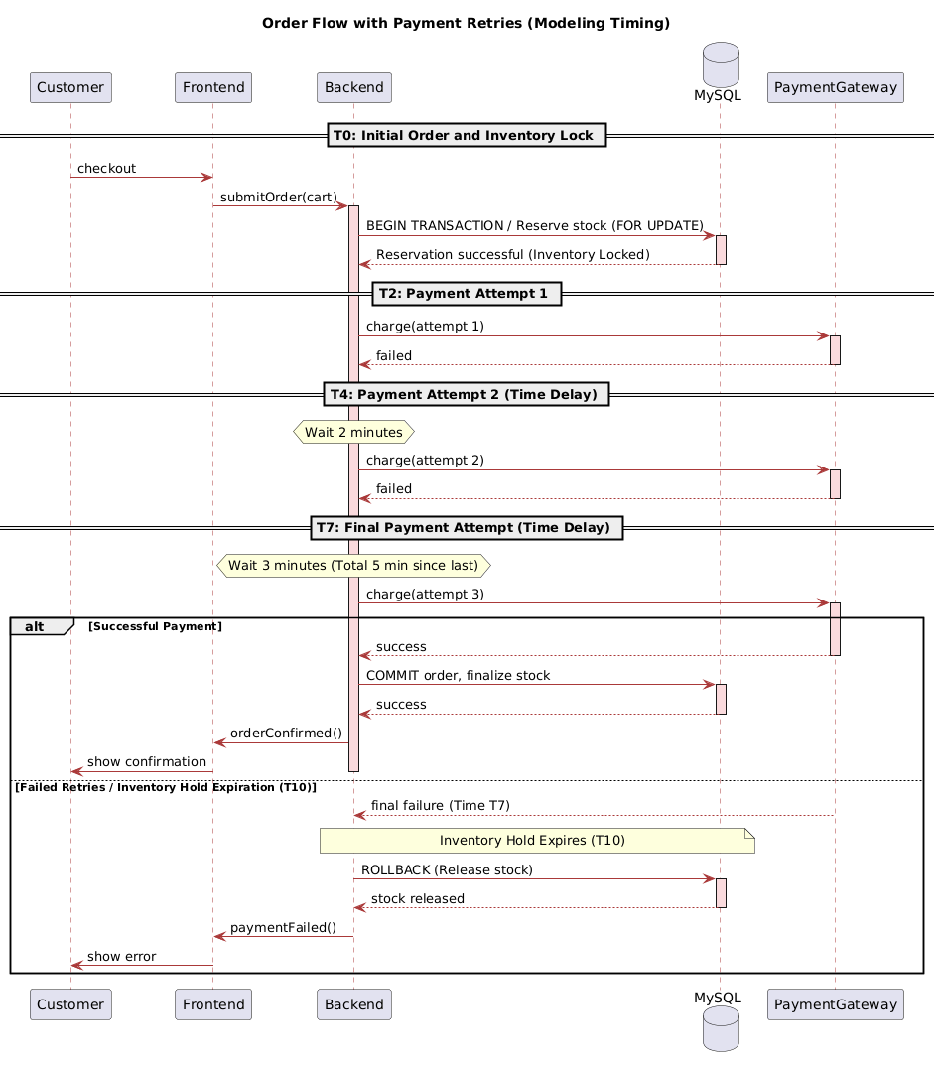

USE CASE DIAGRAM 1 (ACTORS & THEIR RESPONSIBILITIES)
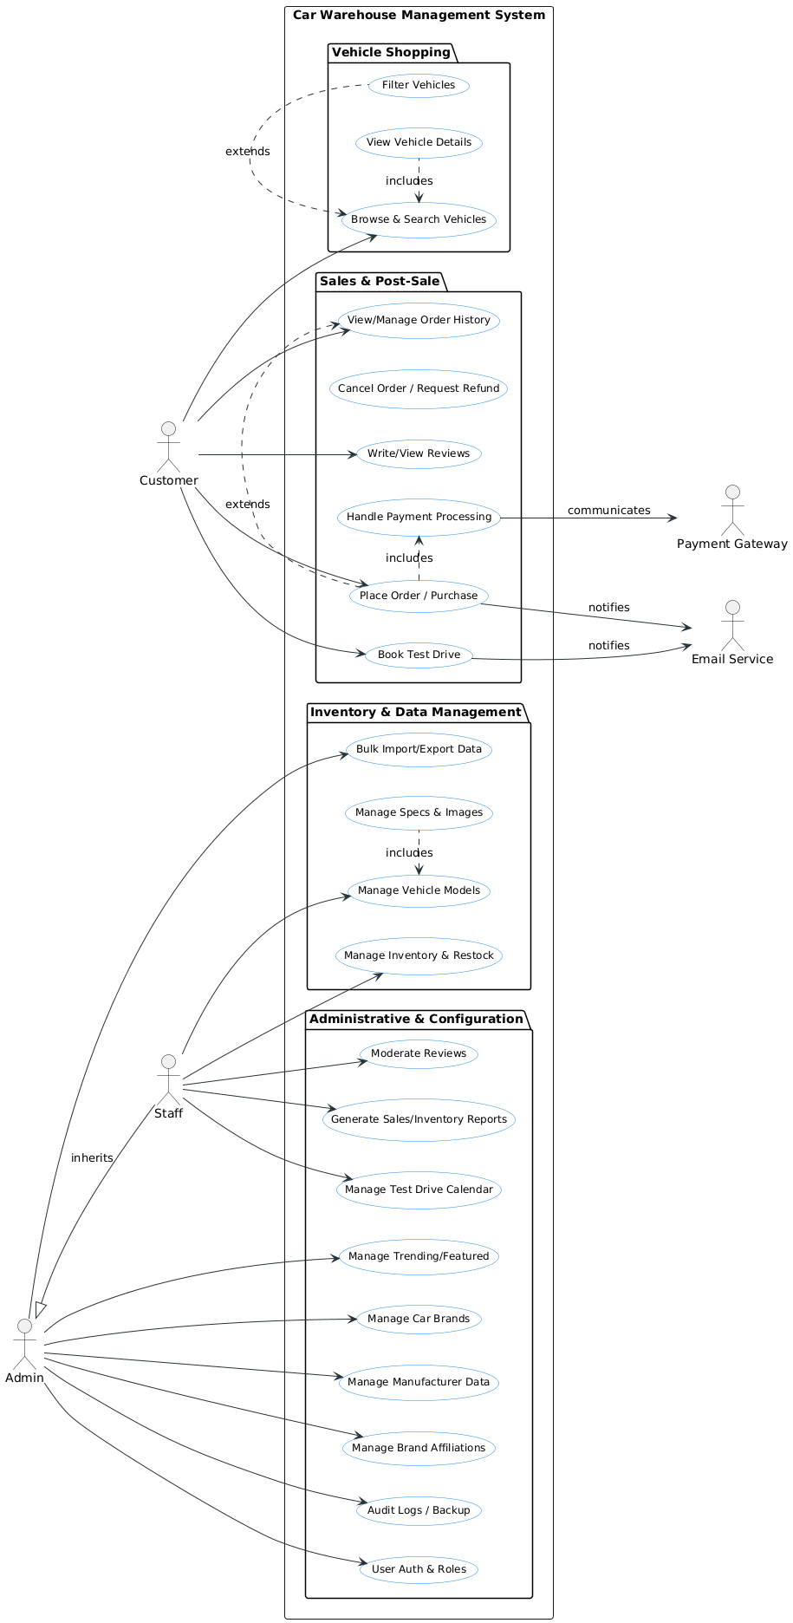

USE CASE DIAGRAM 2 (EXTENSION OF U.C.D-1)
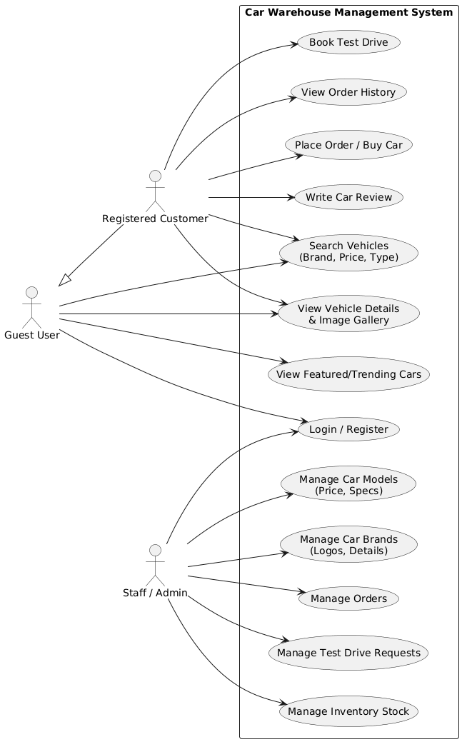

CLASS DIAGRAM 1 (TABLES IN OUR DATABASE)
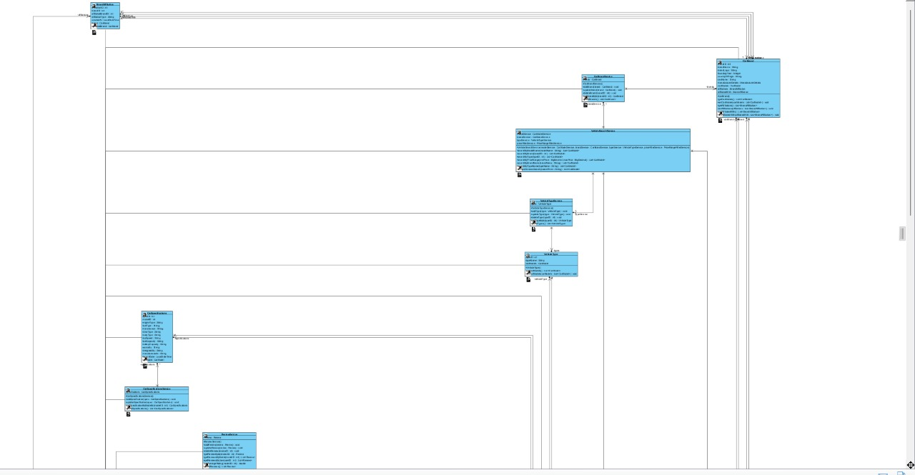

CLASS DIAGRAM 2
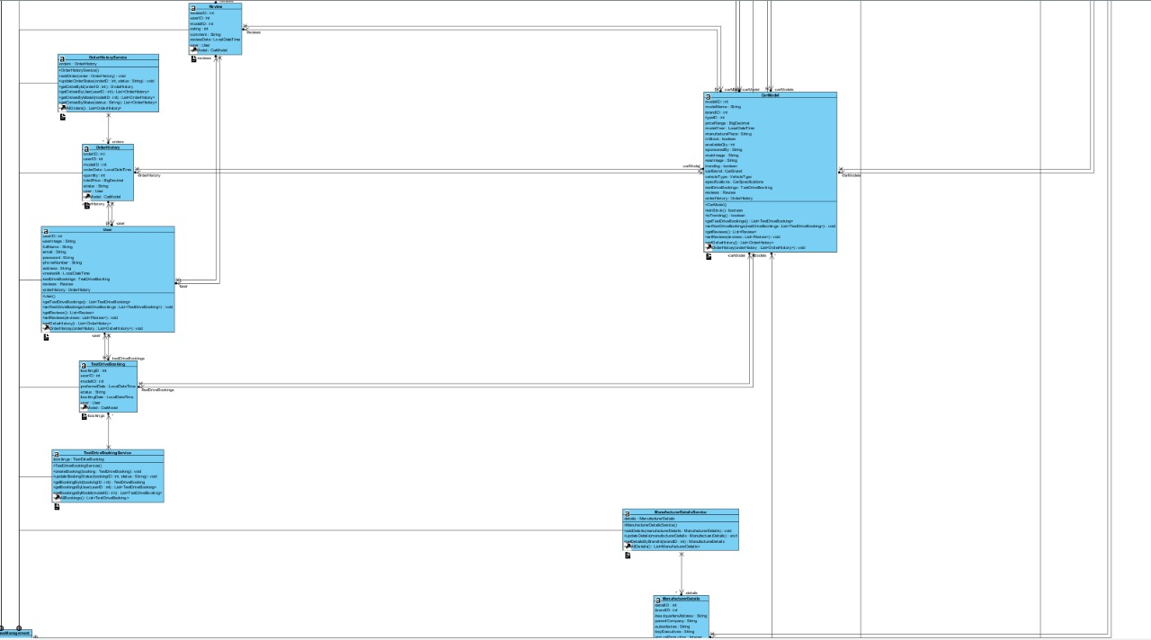

CLASS DIAGRAM 3
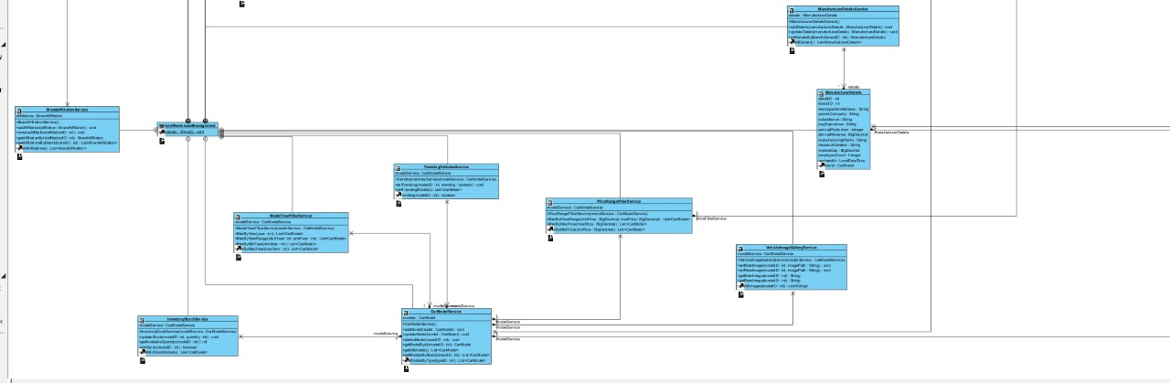

CLASS DIAGRAM 4
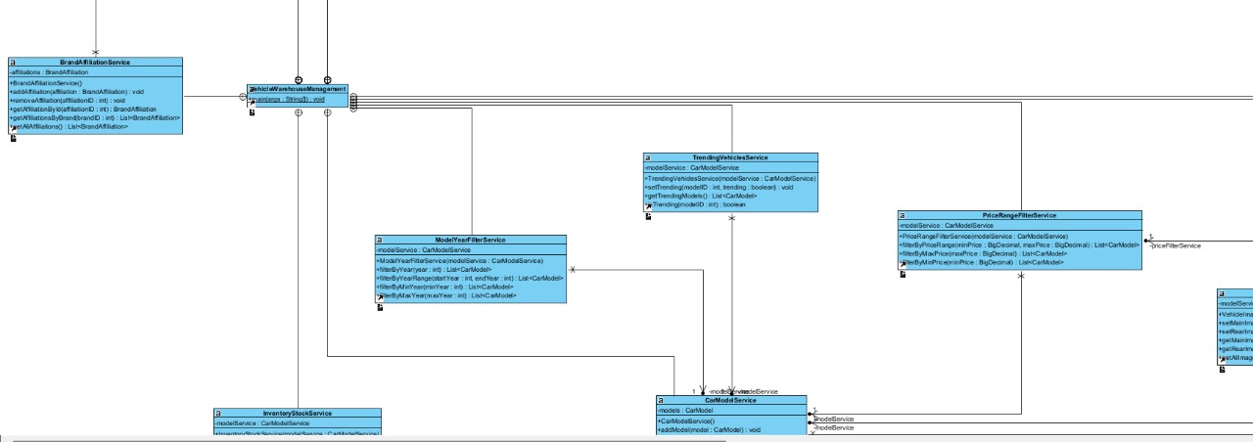

CLASS DIAGRAM 5
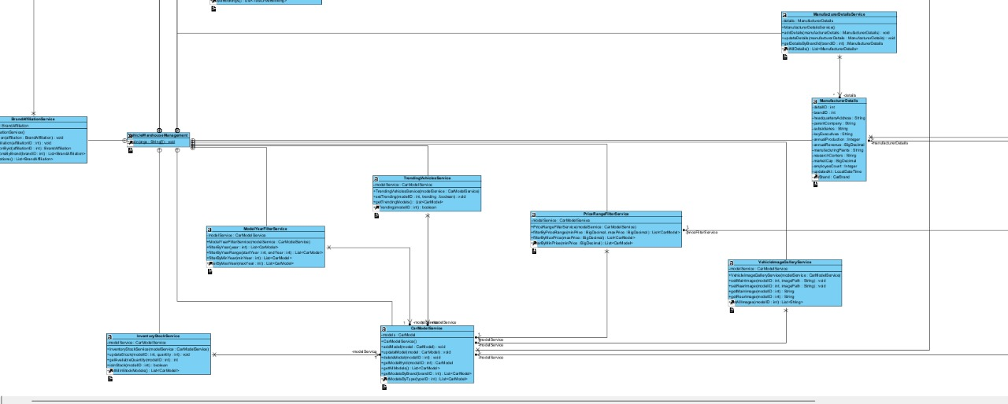

CLASS DIAGRAM 6
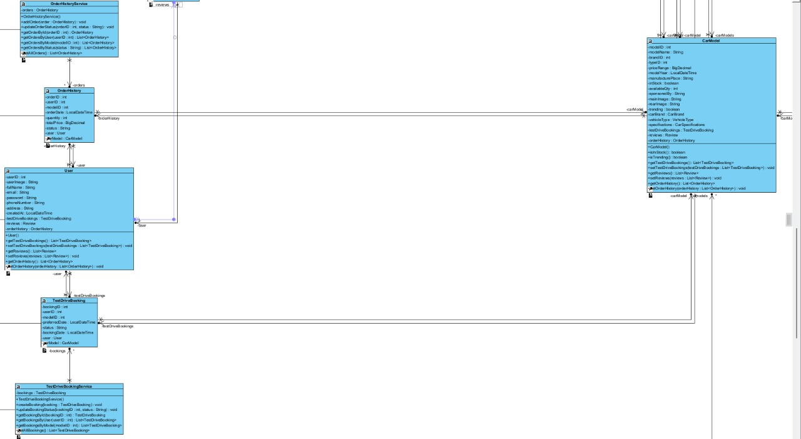

CLASS DIAGRAM 7
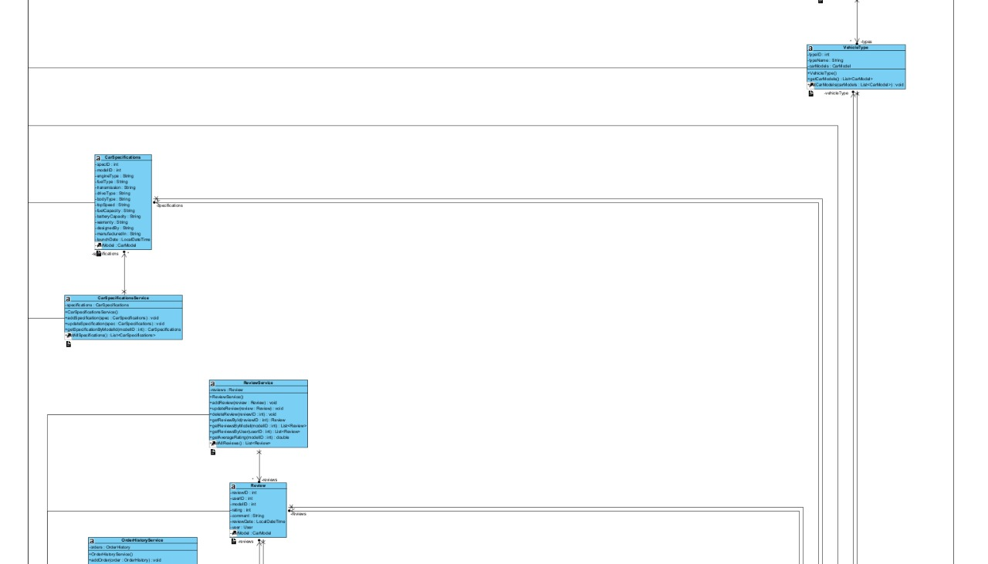

CLASS DIAGRAM 8
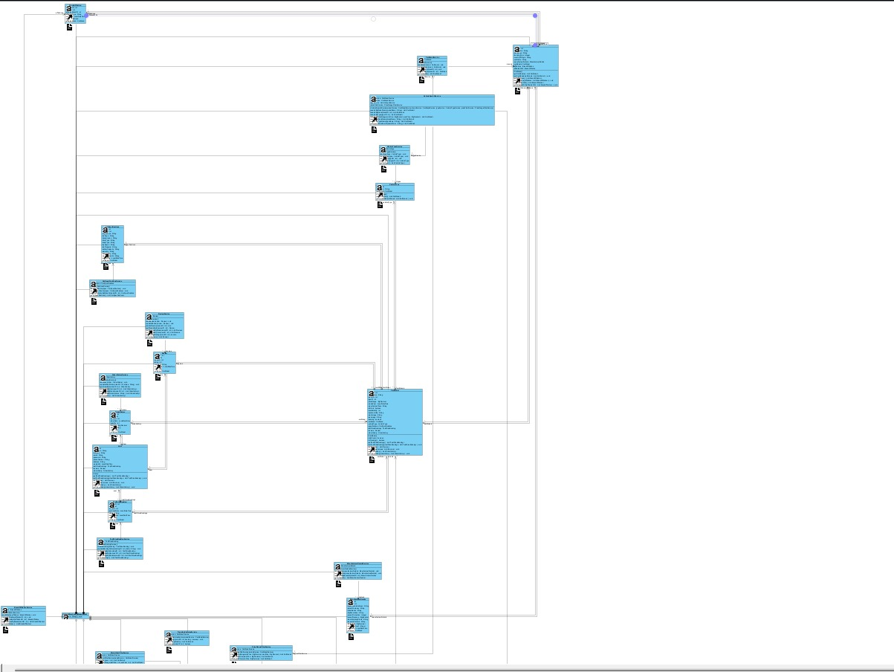

CLASS DIAGRAM 9
